Objective
To outline a standard procedure for product registration managed by the Departamento Autorização de Introdução no Mercado (DAIM) in the National Directorate for Pharmaceutical and Medicines (DNFM), Timor-Leste.

Scope
This procedure is applicable to the registration and renewal of medicinal products for supply in Timor‐Leste, including pharmaceutical products, health supplements and traditional medicines.

The procedure applies to medicine applications seeking registration in both the private and public sector.

Responsibility
The following people are responsible for ensuring this SOP is valid and updated:
- Director DNFM
- Head of Department DAIM

This SOP will be periodically reviewed every 24 months to ensure currency by the responsible parties.

Definitions
    - Applicant – A person based in Timor-Leste applying for medicine registration to DNFM. The person is typically a representative from a company responsible for importing the medicine into Timor-Leste.
    - Application – A set of information submitted by an Applicant to support the registration of a medicine (or multiple medicines) to be supplied in Timor-Leste.
    - Application form – The approved version of the importer application form, as appearing on the DNFM website.
    - Assessment – The process by which DAIM reviews the application and related documents to determine if the proposed product meets legislation, guidelines and standards for quality, safety and efficacy.
    - Importer – A company responsible for obtaining appropriate licenses from Timor-Leste authorities to import medicinal products into Timor-Leste
    - Registration database –an organized collection of structured information maintained by DAIM outlining details regarding medicinal products that have been approved for supply in Timor-Leste by DNFM.
    - Screening Submission List – A list of applications being concurrently submitted by to DNFM.

Procedure
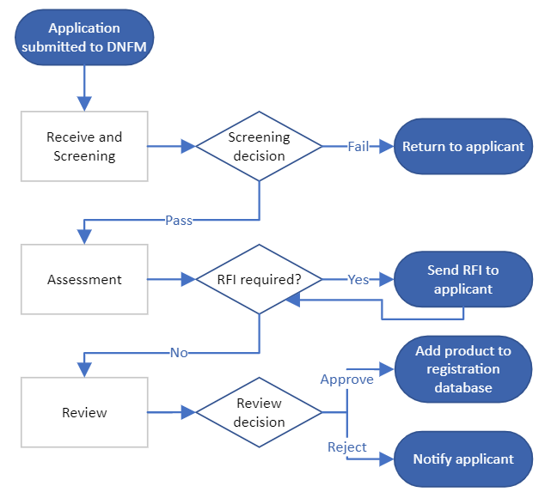
DNFM workflow SOP

Trigger for process commencement
    - Applicant prepares Screening Submission List outlining a list of all Applications being submitted
    - Applicant prepares Application(s) for medicine registration or renewal
    - Applicant submits the Application and Screening Submission List to DNFM office according to instructions in the Application form
    - A complete application will include:
      - Application form completed and signed by the applicant
      - Technical documents, as required in the application form
      - Sample (if Route B)
      - USB stick (if required for large attachments)

Application receipt and screening
    - Administration Assistant receives application from Applicant.
    - Administration Assistant determines if the batch of applications matches the Screening Submission List.
      - If the submitted applications match the Screening Submission List, the Administration Assistant adds signature and date to the Screening Submission List.
      - If any applications are missing, the Administration Assistant informs the company and returns the Application to the Applicant.
    - A copy of signed Screening Submission List is provided to Applicant, and a copy is retained at DNFM.
    - Administration Assistant provides Screening Submission List to Director DAIM.
    - Screening for the complete document as per requirement for registration product. By full fill the criteria.

Assessment
    - Screening Submission List and Applications are assigned by Director DAIM to Assessor
    - Assessor adds signature and date to the Screening Submission List to confirm assignment
    - Assessor creates a new Assessment Template for assessment of the batch of applications. The assessment should be named in the following format:
      - DAIM Assessment – (Importer) – (Month) (Year)
    - Assessor assigns a unique product registration number to each product using the following format:
      - AIMTL/(Year of registration)/(Route A/B/C)(Sequential Number)
      - E.g. for a product registered in 2024 using Route A: AIMTL/2024/A1072
    - Using the Assessment Template, Assessor reviews the data provided in the Application to determine if the product meets appropriate legislation, guidelines and standards for quality, safety and efficacy in Timor-Leste.
    - Assessor ensures that all required documents are provided by the Applicant and records this in the Assessment Template.
    - Assessor provides completed assessment and recommendation to Director DAIM, either:
      - Recommended to proceed to Decision, or
      - Further information is required prior to Decision. Follow process Request For Information (RFI).

Request for Information (RFI)
    - If the Assessor determines during the Assessment that the application is incomplete or does not provide sufficient evidence to demonstrate that the medicine meets legislation, guidelines or standards for quality, safety and efficacy, the Assessor can raise a RFI with the Applicant.
    - The Assessor contacts the Applicant and provides details of the information requested. The Assessor outlines a timeframe for providing a response.
    - The Assessor adds the date to the Screening Submission List to indicate when the applicant has been notified of the request for information.
    - The Assessor adds the date a response is received to the Screening Submission List.
    - If further information is required, the RFI process is repeated.
    - If no further information is required, the Application proceeds to Decision.

Review
    - Head of Department DAIM adds signature and date to the Screening Submission List to confirm receipt.
    - Director DAIM reviews the Assessment to determine whether the application is complete and provides sufficient evidence to demonstrate that the medicine meets legislation, guidelines and standards for quality, safety and efficacy.
    - Director DAIM either:
      - Proceeds Applications to Director DNFM for decision, or
      - Further information is required prior to decision. Return to process Request For Information (RFI).

Decision
    - To approve an Application:
      - Assessor prepares and prints an invoice for payment by the Applicant.
      - The invoice is singed by the Assessor and Director DAIM, then submitted to Director DNFM for signature.
      - Director DNFM adds signature and date to the Screening Submission List to confirm receipt.
      - The Applicant is notified that the invoice is ready for collection and payment.
    - If an Application is not approved, Director DAIM will notify the Applicant.

Registration database
    - If an Application is approved, the Assessor adds details of application to the registration database using information from the Assessment Template, including
      - Importer name
      - Registration number
      - Brand name
      - Generic name
      - Strength
      - Dosage form
      - Essential medicine category
        - Assessor searches the Essential Medicine List (EML) for the active ingredient name, strength and dosage form.
        - If the product is included in the EML, the Assessor enters the VEN category and Health Facility abbreviations, as defined in the EML.
        - If the product is not included in the EML, the Assessor leaves the field blank.
      - Manufacturer
      - Country of origin
      - Route A/B/C
      - Date of registration
      - Date of registration expiry

Process Timeframe
    - Legislated timeframe for completion of process from Application Screening to Decision is 90 calendar days.
    - Target timeframe for complete process is 30 calendar days.

Revision History
Version No. | Date approved | Summary of changes
1.0 |  | Original version

